# Safe Routes to Schools Update - March 2014

Submitted by Wendi Kallins, Program Director

**Promote SR2S Program**

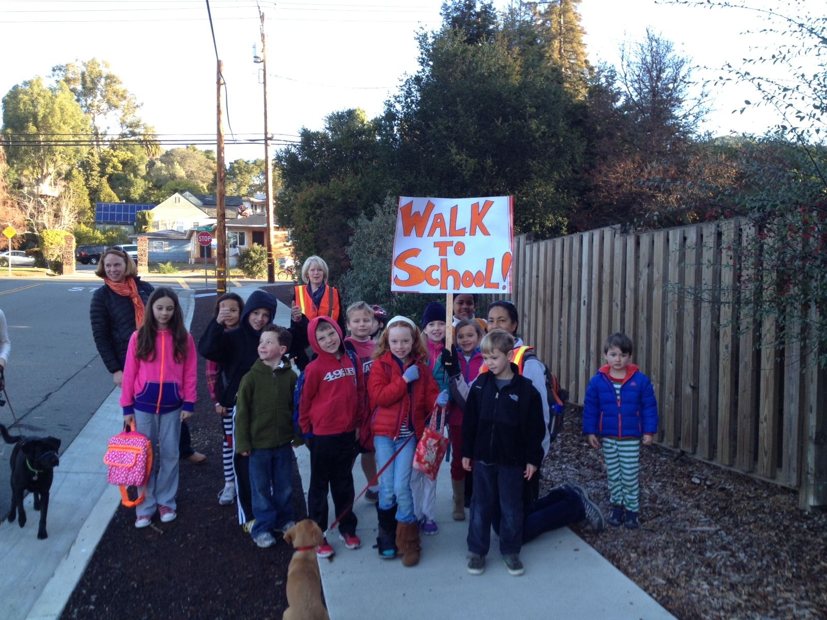[The March Blog](http://sanrafael.patch.com/groups/safe-routes-to-schools---marin-county/p/making-the-walk-to-school-a-social-routinehttp:/millvalley.patch.com/groups/safe-routes-to-schools---marin-county/p/all-aboard-the-tiburon-bike-train) featured the Coleman Walking School Bus. The [newsletter](http://archive.constantcontact.com/fs198/1102463494934/archive/1116759315526.html) featured Kent Middle Schools’ Pi event on 3.14 and a report from the National Center on the increase due to Safe Routes to Schools. Wendi met with the students from the California Academy of the Arts again to work out the logistics for the video shooting. She obtained permission from the schools and set up interviews and the schedule. Our Facebook reach has peaked at a record 343 as we fine tune and figure out what attracts views.

**Task Force Updates**

We held task force meetings for Novato and Mill Valley. In Novato they discussed the implementation of the improvements to Lynwood and Sinaloa schools and asked for help to support the Sinaloa sidewalk. They also discussed the crosswalks along Ignacio Blvd.

In Mill Valley the group received an update on the projects in both the city of Mill Valley and in the unincorporated areas. Mill Valley Middle School worked on developing route maps with the students and presented the results. She described the process for the other schools.

**Education**

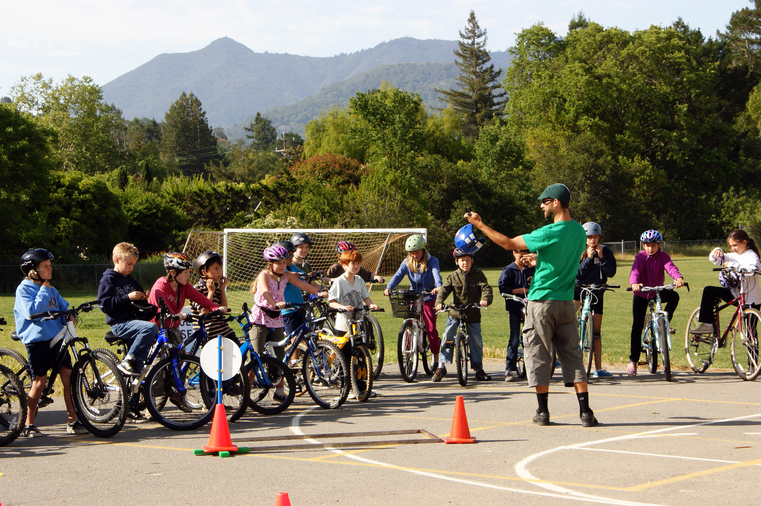James revamped the Drive that Bike presentation for high school and developed a presentation for the Ecology classes at Redwood. He made improvements to the send-home letters for 2nd, 4th and 6th grade and upgraded other class materials.

**Classes Taught**

***Bolinas-Stinson School District***

*Bolinas Elementary School*

Stop, Look and Listen for 1 class and 26 students.

Walk Around the Block for 1 class and 25 students.

Bike Rodeo for 1 class and 32 students.

Bike Safety for 1 class and 32 students.

Traffic Safety for 1 class and 32 students.

*Bolinas Middle School*

Drive that Bike for 2 classes and 42 students.

Outdoor Bike Drills for 2 classes and 42 students.

***Dixie School District***

*Miller Creek Middle School*

Drive that Bike for 3 classes and 120 students.

Outdoor Bike Drills for 1.5 classes and 60 students.

***Larkspur Corte Madera School District***

*Neil Cummins Elementary School*

Traffic Safety for 6 classes and 150 students.

*Hall Middle School*

Drive that Bike for 2 classes and 60 students.

***Mill Valley School District***

*Edna Maguire Elementary School*

Stop, Look and Listen for 4 classes and 95 students.

Traffic Safety for 4 classes and 100 students.

Walk Around the Block for 4 classes and 96 students.

*Strawberry Point Elementary School*

Stop, Look and Listen for 2 classes and 46 students.

***Ross Valley School District***

*White Hill Middle School*

Drive that Bike for 8 classes and 280 students

Outdoor Bike Drills for 8 classes and 280 students.

***San Rafael School District***

*Glenwood Elementary School*

Bike Rodeo for 3 classes and 75 students.

*Laurel Dell Elementary School*

Bike Rodeo for 2 classes and 54 students.

***Tamalpais High School District***

*Redwood High School*

Ecology presentation with Joe Stewart for 3 classes and 63 students.

***Private Schools***

*Cascade Canyon*

Bike Rodeo for 1 class and 24 students.

Outdoor Bike Drills for 1 class and 24 students.

*St. Patrick*

Bike Rodeo for 1 class and 30 students.

**Encouragement**

We ordered the erasers for Bike to School Day and prepared the email blasts to go out to prepare for the event. Laura continues to support the team leaders for Walk and Roll Wednesdays providing supplies and promotional materials.

**Teen Clubs**

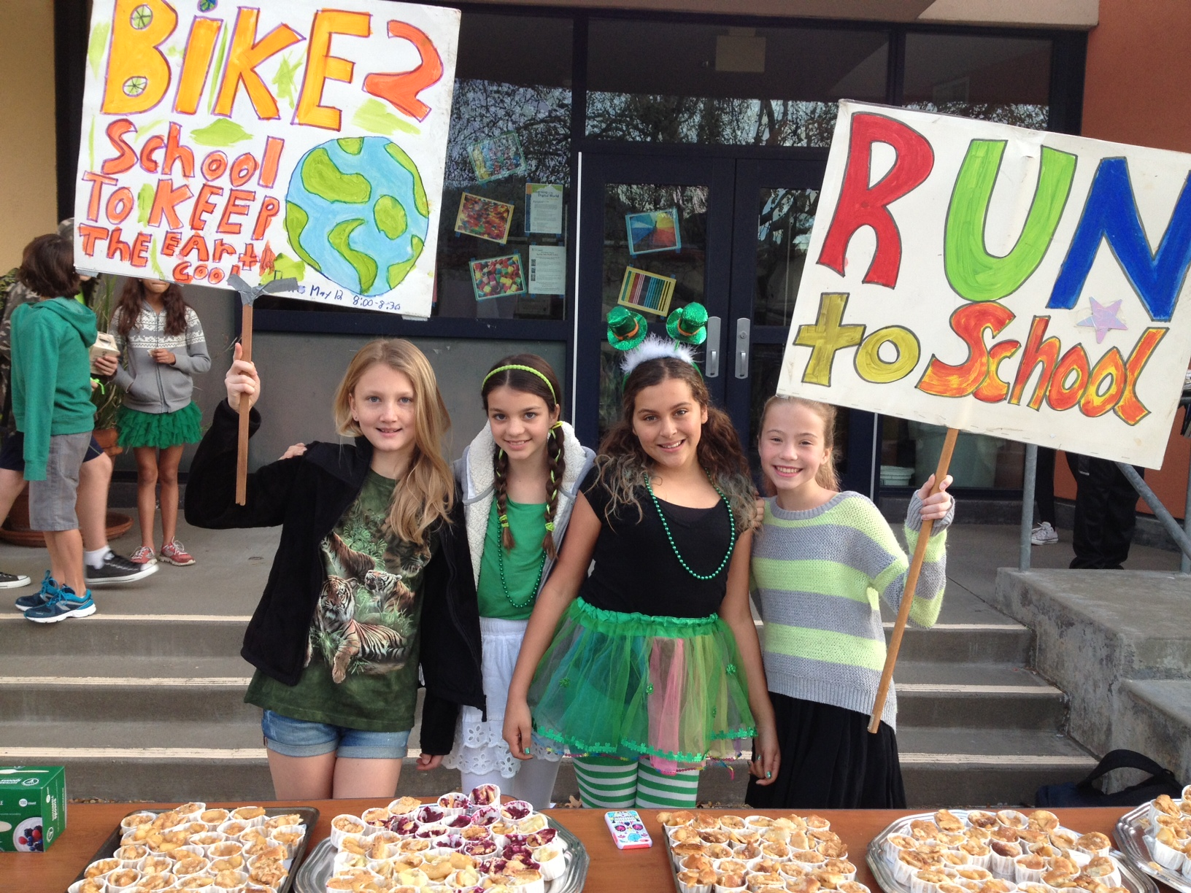Staff worked with White Hill, Drake, Redwood, Kent, Miller Creek, Hall, Davidson and Mill Valley Middle School. Kent held a special Pi Walk and Roll day on 3/14/14 (the number Pi is 3.14) with pies and also a St. Patrick’s Day green theme. Miller Creek is putting the finishing touches on it’s route maps in preparation of the launch of the 50% challenge. Davidson girl scouts are preparing a presentation to the Chief of Police and to the Town Council. MVMS and Kent are preparing a bike donation day to collect bikes to give away to needy children. Ecology presentations were given to Joe Stewart’s science classes at Redwood High School (see education)

**SchoolPool**

We have hired a bi-lingual contractor to assist with promoting SchoolPool to the Hispanic communities. She is a neighborhood captain at Bacich. Wendi continued to mine the data and create lists of potential neighborhood captains. These lists were provided to team leaders in San Rafael and Novato.